**CTEC 3350  
Web Communication Design and Development 2**

**Flexbox – align-self: \***

Screenshot 1

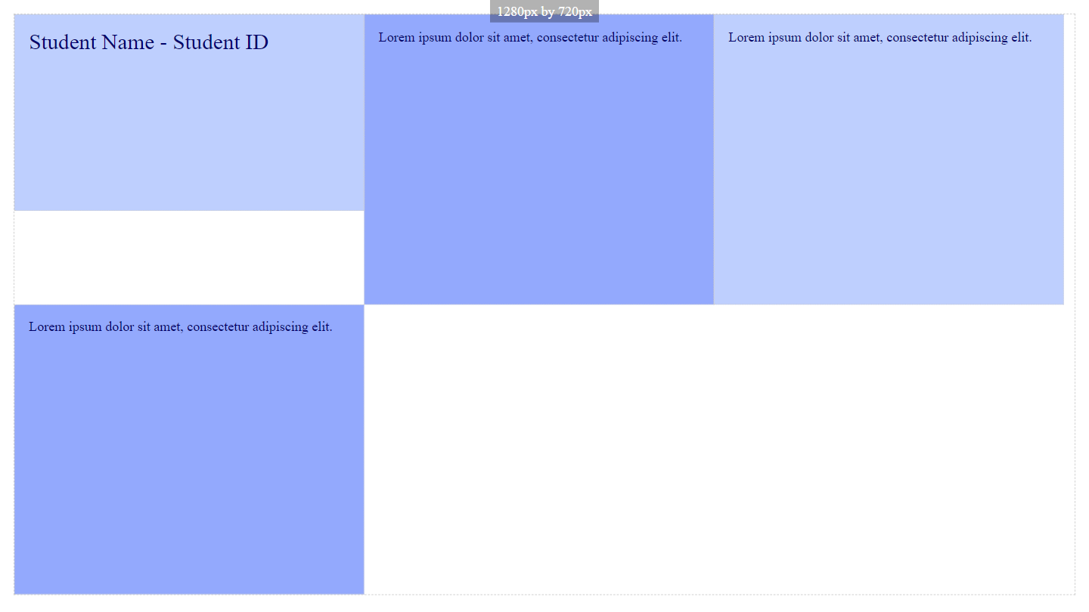

Paste a copy of your screenshot including your Student Name and Student ID (here)

Paste the style declaration you used to make your screenshot happen.

align-self:

Screenshot 2

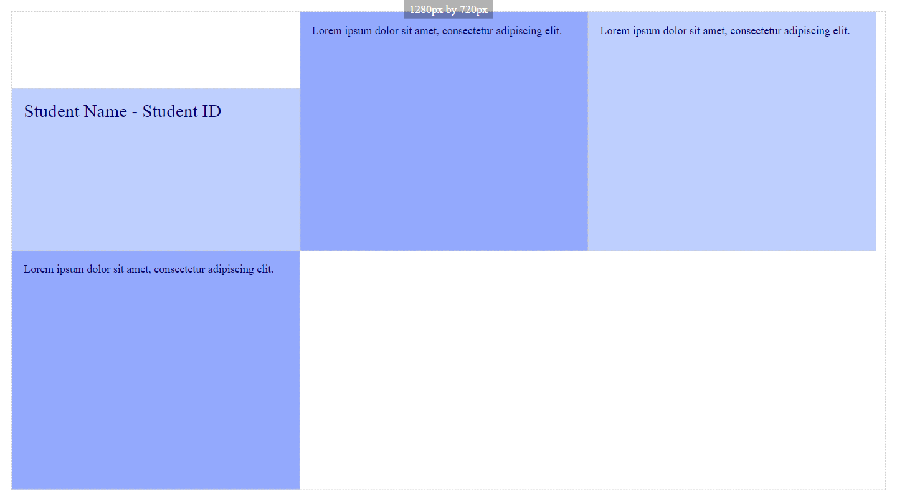

Paste a copy of your screenshot including your Student Name and Student ID (here)

Paste the style declaration you used to make your screenshot happen.

align-self:

Screenshot 3

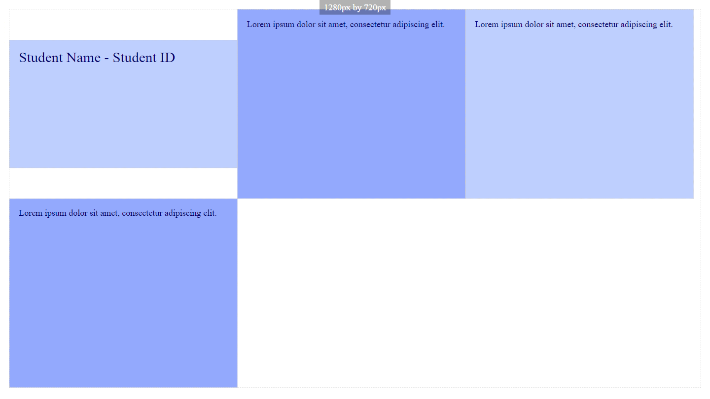

Paste a copy of your screenshot including your Student Name and Student ID (here)

Paste the style declaration you used to make your screenshot happen.

align-self:

Screenshot 4

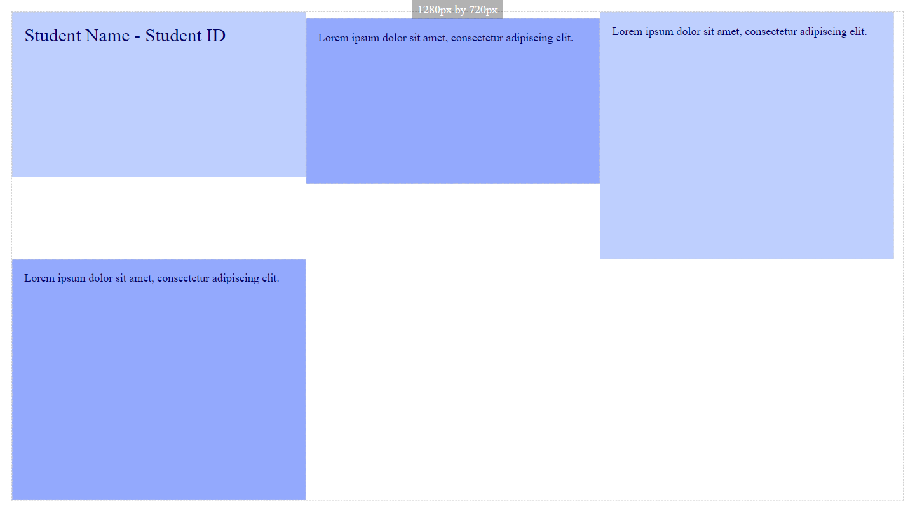

Paste a copy of your screenshot including your Student Name and Student ID (here)

Paste the style declaration you used to make your screenshot happen.

align-self:

Screenshot 5

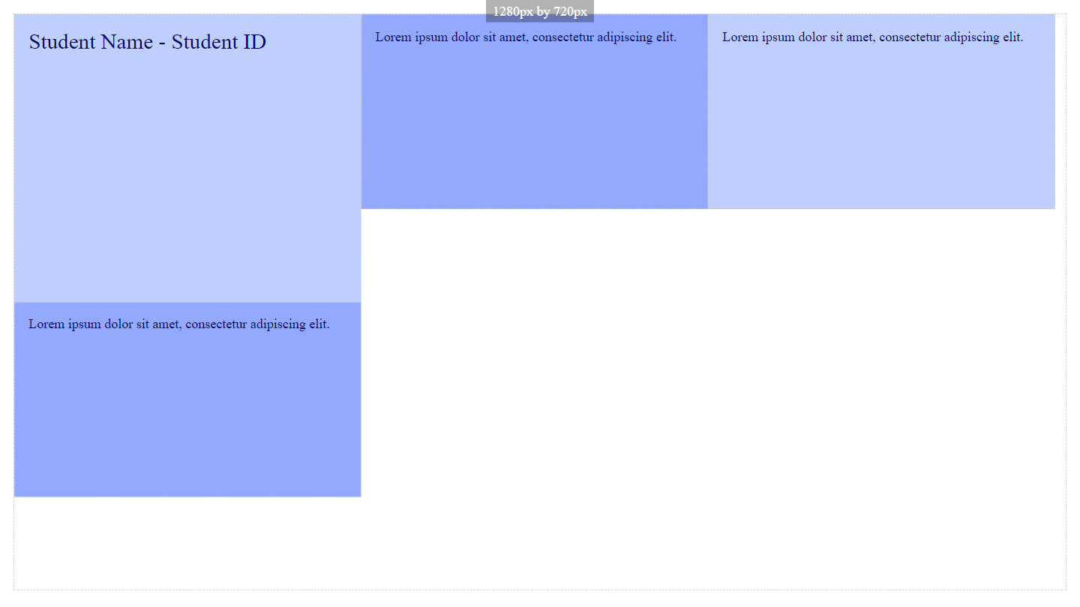

Paste a copy of your screenshot including your Student Name and Student ID (here)

Paste the style declaration you used to make your screenshot happen.

align-self:

Screenshot 6

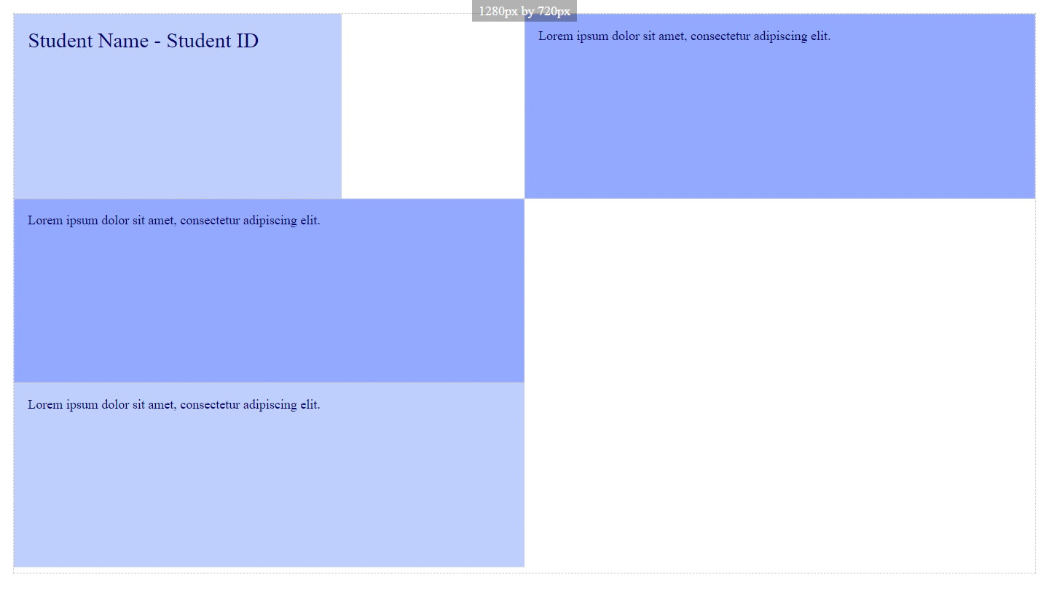

Paste a copy of your screenshot including your Student Name and Student ID (here)

Paste the style declaration you used to make your screenshot happen.

align-self:

Screenshot 7

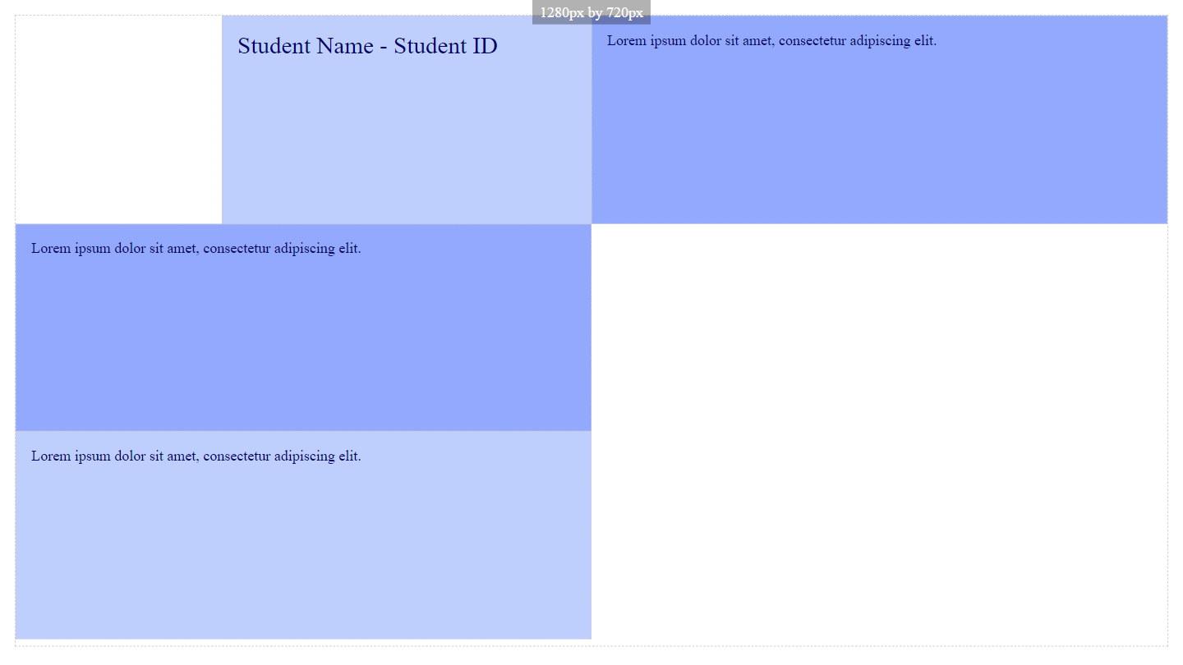

Paste a copy of your screenshot including your Student Name and Student ID (here)

Paste the style declaration you used to make your screenshot happen.

align-self:

Screenshot 8

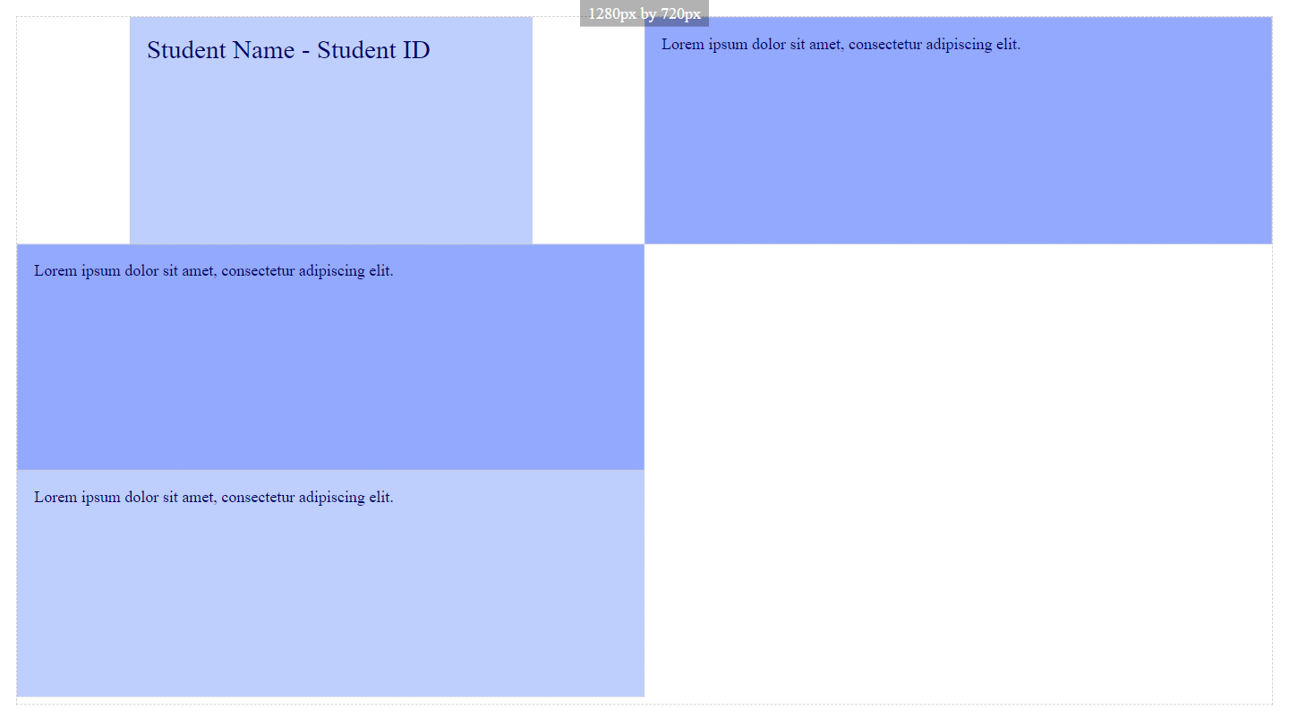

Paste a copy of your screenshot including your Student Name and Student ID (here)

Paste the style declaration you used to make your screenshot happen.

align-self:

Screenshot 9

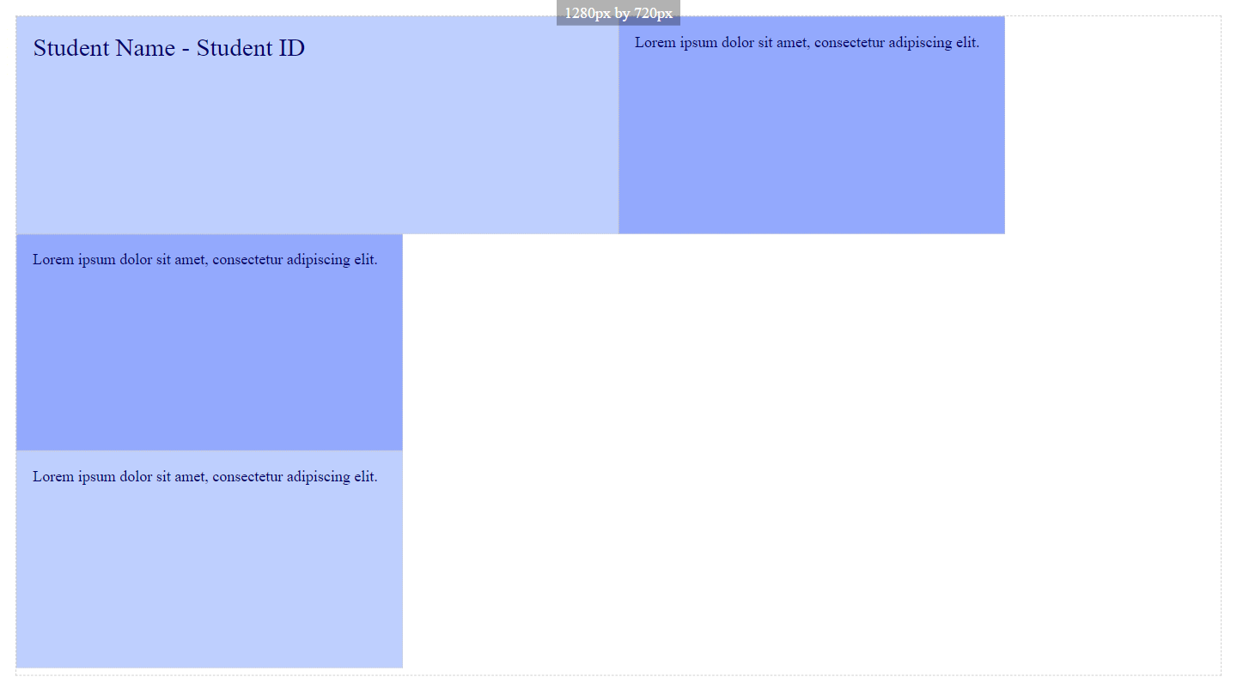

Paste a copy of your screenshot including your Student Name and Student ID (here)

Paste the style declaration you used to make your screenshot happen.

align-self: